DELTA TEAM

Adriana Rodriguez

Erik Hernandez

Somsak Bounchareune

Taib Elbaroudi

WILLSON FINANCIAL

**Revised ERD:**

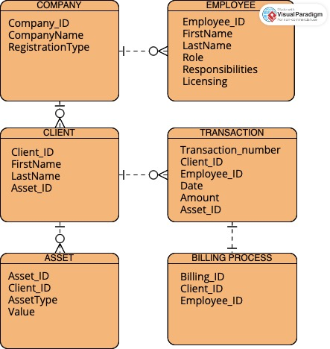

**Python Script & Screenshot of the Data Displayed from the Tables:**

import mysql.connector

user = "root"

password = ""

database = "financial_database"

# Establish a connection to the database

connection = mysql.connector.connect(

user=user,

password=password,

database=database

)

# Cursor

cursor = connection.cursor()

try:

# Display data from Company table

print("Data in Company table:")

cursor.execute("SELECT * FROM Company")

for row in cursor.fetchall():

print(row)

# Display data from Employee table

print("\nData in Employee table:")

cursor.execute("SELECT * FROM Employee")

for row in cursor.fetchall():

print(row)

# Display data from Client table

print("\nData in Client table:")

cursor.execute("SELECT * FROM Client")

for row in cursor.fetchall():

print(row)

# Display data from Transaction table

print("\nData in Transaction table:")

cursor.execute("SELECT * FROM Transaction")

for row in cursor.fetchall():

print(row)

# Display data from Asset table

print("\nData in Asset table:")

cursor.execute("SELECT * FROM Asset")

for row in cursor.fetchall():

print(row)

# Display data from BillingProcess table

print("\nData in BillingProcess table:")

cursor.execute("SELECT * FROM BillingProcess")

for row in cursor.fetchall():

print(row)

finally:

# Close the cursor and connection

cursor.close()

connection.close()

